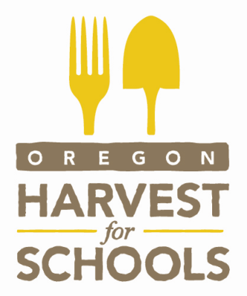

Molalla River School District’s “Harvest of the Month” for 2014/2015

Month | Fruit or Vegetable
September | Tomatoes
October | Corn
November | Cabbage
January | Pears
February | Apples
March | Potatoes
April | Kale
May | Salad Greens

